**Homework 3**

**STAT: 4510: 0001**

**Yubing Li 00808366**

**1. Mercury Contamination**

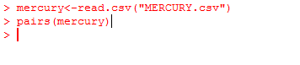**(a)** **Scatterplot matrix:**

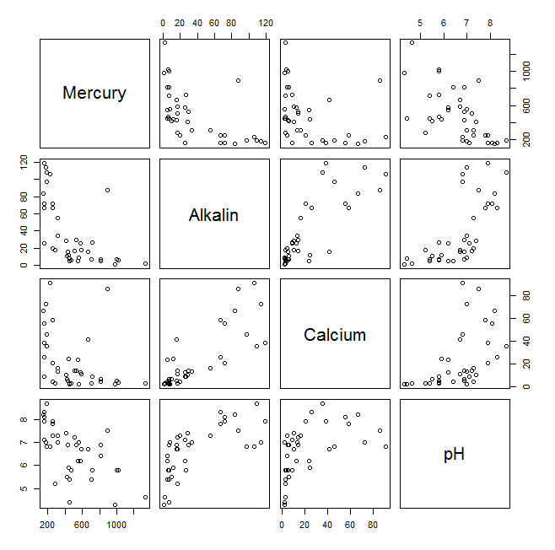

The response variable is Y: Mercury.

The explanatory variables are X1: Alkalin; X2: Calcium; X3: pH.

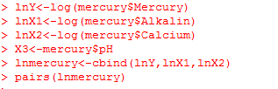**(b) Scatterplot matrix of log:**

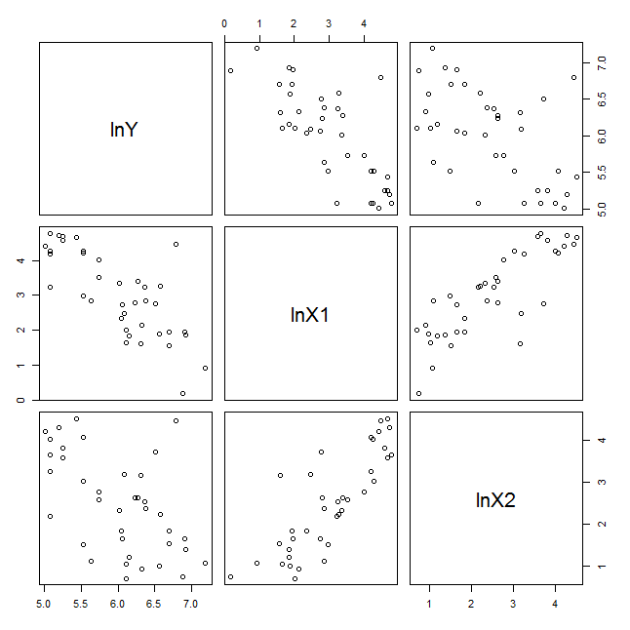

For lnY and lnX1:

The scatterplot with the response variable lnY and the explanatory variable lnX1 is the one in the middle of the 1st row. It shows a moderately strong, negative linear relationship.

For lnY and lnX2:

The scatterplot with the response variable lnY and the explanatory variable lnX2 is the one on the left of the 1st row. The graph does not indicate a linear relationship between them.

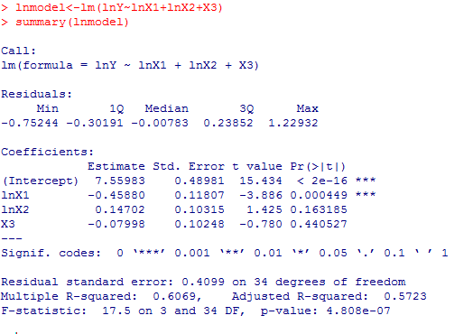**(c) Model:**

The model is: l $\hat{og(Y)}$ = 7.5598 – 0.4588×log(X1) + 0.1470×log(X2) -0.07998×X3

**(d) Interpret $\hat{β3}$:**

log(Y) = 7.5598 – 0.4588×0 + 0.1470×0 – 0.07998×X3

Y = e7. 5598 – 0.4588×log(X1) + 0.1470×log(X2) ÷e0.07998×X3

β3 is the expected change in standardized mercury level related to per unit change in pH (X3), assuming all other explanatory variables are held fixed. $\hat{β3}$ is the unbiased estimator for β3.

For per unit change in pH, the standardized mercury level is going to be divided by 1.0833.

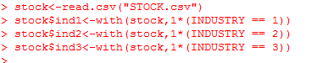**2. Stocks**

**(a) Linear model**

$\hat{PE}$ = 4.0509 + 0.6400(ProfitMargin) + 0.2995(GrowthRate) – 2.7795(ind2) – 2.2548(ind3)

with the oil industry being the base level.

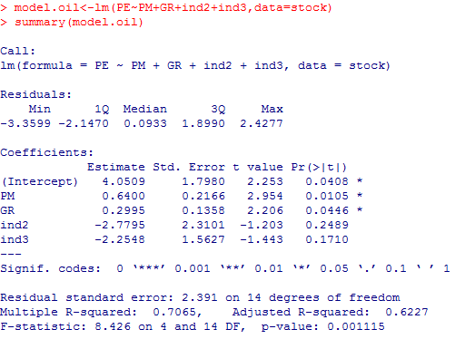

**(b) Interpret the coefficient of indicator for ind3:**

We can interpret the regression coefficient associated with ind3, -2.2548, to be the difference between the “computer/electronics” industry and the “oil” industry, holding other explanatory variables fixed.

**(c) Drug/healthcare base level:**

|  |  |  |
| --- | --- | --- |
| Oil | 4.0509 | 4.0509 |
| Drug/healthcare | 4.0509-2.7795 | 1.2714 |
| Computer/elec. | 4.0509-2.2548-1.2714 | 0.5247 |

$\hat{PE}$ = 1.2714 + 0.6400(ProfitMargin) + 0.2995(GrowthRate) + 2.7795(ind1) + 0.5247(ind3)

with the drug/healthcare industry being the base level

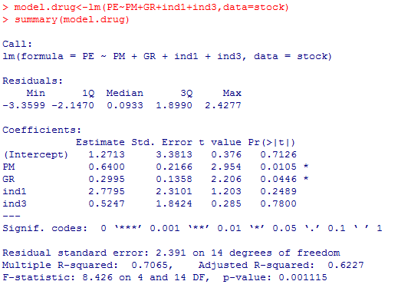(Check the answer by fitting the new model, verified)

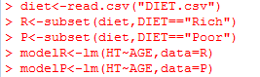**3. Diet**

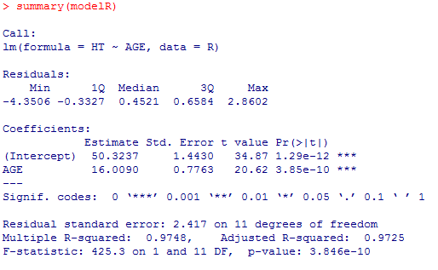**(a) Separate LSRLs**

LSRL of HT on AGE for Protein-Rich: rich = 50.3237 + 16.0090 × (Age)

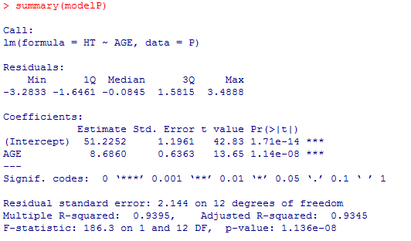

LSRL of HT on AGE for Protein-Poor: poor = 51.2252 + 8.6860 × (Age)

**(b) Single scatterplot**

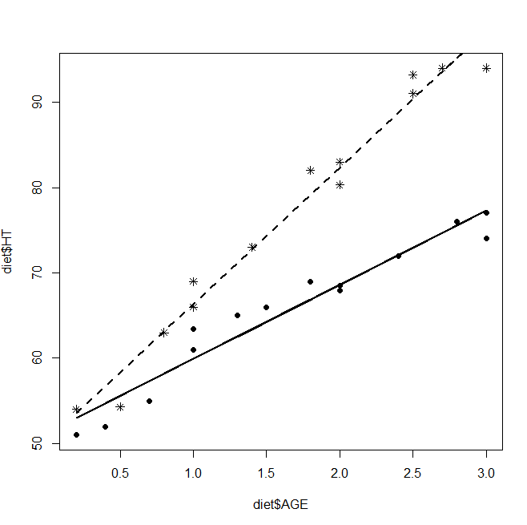 LSRL of HT on AGE for Protein-Rich

LSRL of HT on AGE for Protein-Poor

* Group of Protein-Rich

● Group of Protein-Poor

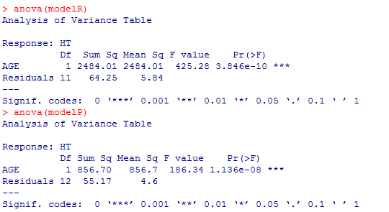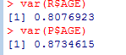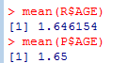**(c) (d) (e) on the handwritten page.**

**4. Single regression model for Problem 3:**

**(a) Model is:**

= β0 + β1×(Age) + β2×(Diet) + β3×( Age* Diet) + ε

with indicator variable Diet = 1 if it’s Protein-Rich; Diet = 0 if it’s Protein-Poor.

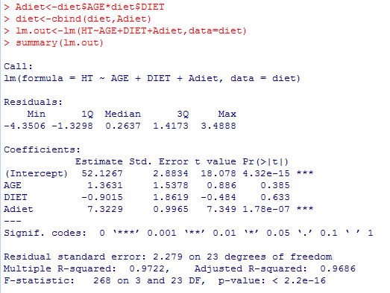**(b) Fit the model:**

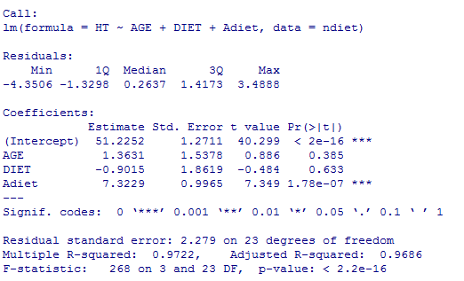

$\hat{Height}$ = 51.2252+ 1.3631×(Age) – 0.9015×(Diet) + 7.3229×( Age* Diet)

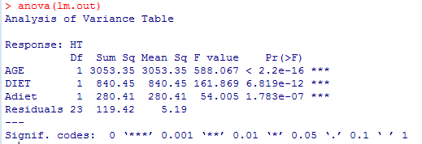**(c) (d) (e) on the handwritten page.**